Note for MC: we have a map of 1922 Gravesend in forum. SSID: 30676665

**20C Gravesend**

**Hayley Smith**

It would be wrong to assume that Gravesend’s national and international connections were only supplied by the town’s proximity to the River Thames and to London. Indeed, an airport built in 1932 experienced a transformation from a civilian airfield into a fighter station during the Second World War, leading to the town being heavily bombed by the German air force. In fact, the German war campaign executed during the last months of 1940 and the early months of 1941 – otherwise known as ‘The Blitz’ – saw Gravesend, amongst many other cities and towns, suffer through some of the worst bombing raids. During this time, the railway line between Gravesend and Northfleet was bombed; the War Memorial at Windmill Gardens was damaged; and Gravesend’s airport was attacked in an air raid that killed two soldiers.[1]

Windmill Hill – a nineteenth century tourist hotspot named after its former windmills and offering visitors extensive views over the Thames – also suffered during the First World War when it was bombed by an Imperial German Navy airship. Today it is possible to see three markers where these bombs hit the site.

The first windmill was built on the hill during the reign of Queen Elizabeth I and positioned at the highest point in Gravesend. Unfortunately the mills were destroyed over the years, but Windmill Hill remains one of twenty-four conservation areas in Gravesham. Visitors travelling to Windmill Hill will find the aforementioned markers of the World War I zeppelin bombs alongside a beacon erected on the 400th anniversary of the advance of the Spanish Armada. This beacon was raised and lit in 1988 and resembles the original beacon constructed in 1377 – under King Richard II’s reign – when the Hill was known as ‘Rouge Hill’.[2]

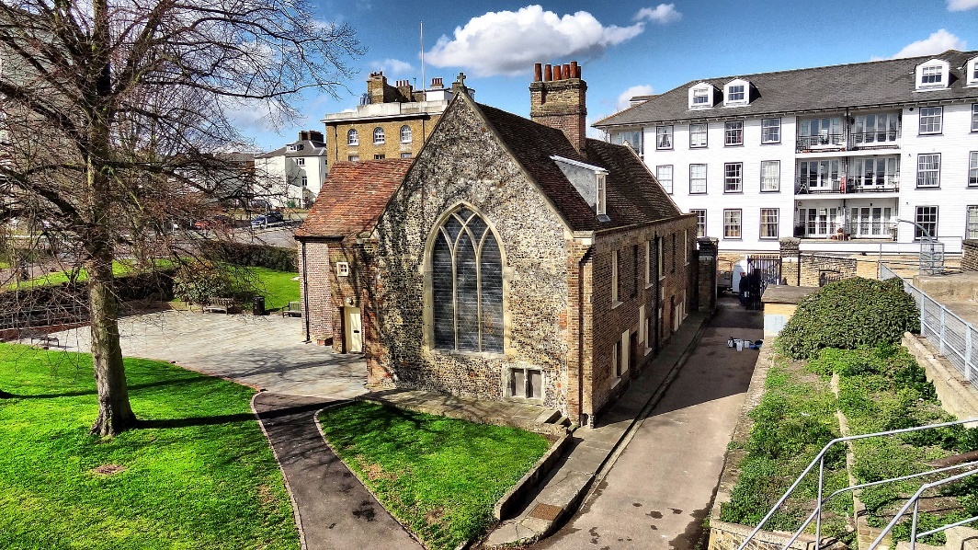

Like Gravesend’s airfield, the basement of Milton Chantry – the oldest surviving building in Gravesend, constructed in 1322 by Aymer de Valence, Earl of Pembroke – also underwent a conversion during the Second World War, emerging as a gas decontamination chamber. Before that, though, the building originally functioned as a leper hospital, later being converted into a Tudor chantry chapel, then re-establishing itself as a public house and changing once again into Georgian barracks before its conversion during WWII. Visitors are still able to see the fourteenth century timber roof at the chantry, along with a collection of heritage items relating to Gravesend, including several Roman remains unearthed within the area.[3]

Map of Gravesend from 1946 –“Gravesend” on Wikipedia.

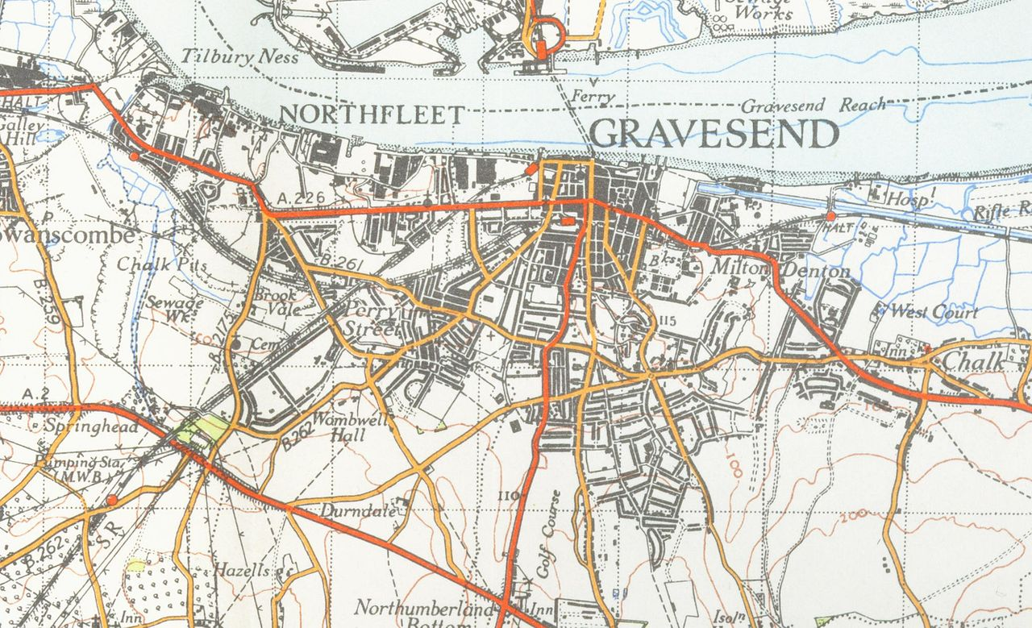

1. <http://www.discovergravesham.co.uk/gravesend-chronology/1938-1941.html>
2. <https://www.visitkent.co.uk/attractions/windmill-hill-gardens-2854/>
3. <https://www.english-heritage.org.uk/visit/places/milton-chantry>